# Exam Preparation – 7 April 2025

**Link to contest**: <https://judge.softuni.org/Contests/5154/JS-Front-End-Regular-Exam-15-December-2024>

## Problem 1 – Farm Management System

*You are the owner of a farm in a small picturesque village. Your team consists of farmers, and you need to manage their tasks and the areas they work in. Each farmer has a name, a work area, and a list of tasks they can perform.*

On the **first line** of the input, you will **receive** an integer **n** – the **number of farmers** in your team. On the next **n** lines, the **details of each farmer** will follow in the format:

"{farmer name} {work area} {task 1,task 2,...}"

The work area represents the location where the farmer works (e.g., garden, barn, apiary), and the list of tasks includes the activities the farmer can perform.

After forming your team, you will receive different commands, separated by " / ", until the command "End" is given. There are three types of actions farmers can perform:

**"Execute / {farmer name} / {work area} / {task}"**

* If the farmer is in the correct work area and can perform the task, print:

**"{farmer name} has executed the task: {task}!"**

* If the farmer is not in the correct work area or cannot perform the task, print:

**"{farmer name} cannot execute the task: {task}."**

**"Change Area / {farmer name} / {new work area}"**

* The farmer changes their work area. Print:

**"{farmer name} has changed their work area to: {new work area}"**

**"Learn Task / {farmer name} / {new task}"**

* If the farmer already knows the task, print:

**"{farmer name} already knows how to perform {new task}."**

* Otherwise, add the new task to their list and print:

**"{farmer name} has learned a new task: {new task}."**

### Input

* On the **first line**, you will receive an integer **n**.
* On the next **n** lines, you will receive **details** about the **farmers**.
* After that, you will receive **commands** until the "**End**" command.

### Output

* **Print** the results **of each command**.
* At the end, print all farmers with their updated work areas and task lists in the format:

**"Farmer: {farmer name}, Area: {work area}, Tasks: {task 1, task 2, ...}"**

* The **Tasks** should be printed in **alphabetical order.**

### Constraints

* The names of the farmers will be unique.
* All given commands will be valid.

### Examples

|  |  |
| --- | --- |
| **Input** | **Output** |
| [  "2",  "John garden watering,weeding",  "Mary barn feeding,cleaning",  "Execute / John / garden / watering",  "Execute / Mary / garden / feeding",  "Learn Task / John / planting",  "Execute / John / garden / planting",  "Change Area / Mary / garden",  "Execute / Mary / garden / cleaning",  "End"  ] | John has executed the task: watering!  Mary cannot execute the task: feeding.  John has learned a new task: planting.  John has executed the task: planting!  Mary has changed their work area to: garden  Mary has executed the task: cleaning!  Farmer: John, Area: garden, Tasks: planting, watering, weeding  Farmer: Mary, Area: garden, Tasks: cleaning, feeding |
| **Input** | **Output** |
| [  "3",  "Alex apiary harvesting,honeycomb",  "Emma barn milking,cleaning",  "Chris garden planting,weeding",  "Execute / Alex / apiary / harvesting",  "Learn Task / Alex / beeswax",  "Execute / Alex / apiary / beeswax",  "Change Area / Emma / apiary",  "Execute / Emma / apiary / milking",  "Execute / Chris / garden / watering",  "Learn Task / Chris / pruning",  "Execute / Chris / garden / pruning",  "End"  ] | Alex has executed the task: harvesting!  Alex has learned a new task: beeswax.  Alex has executed the task: beeswax!  Emma has changed their work area to: apiary  Emma has executed the task: milking!  Chris cannot execute the task: watering.  Chris has learned a new task: pruning.  Chris has executed the task: pruning!  Farmer: Alex, Area: apiary, Tasks: beeswax, harvesting, honeycomb  Farmer: Emma, Area: apiary, Tasks: cleaning, milking  Farmer: Chris, Area: garden, Tasks: planting, pruning, weeding |

## Problem 2. Eco Events

**Environment Specifics**

Please be aware that every JS environment may **behave differently** when executing code. Certain things that work in the browser are not supported in **Node.js**, which is the environment used by **Judge**.

The following actions are **NOT** supported:

* **.forEach()** with **NodeList** (returned by **querySelector()** and **querySelectorAll()**)
* **.forEach()** with **HTMLCollection** (returned by **getElementsByClassName()** and **element.children**)
* using the **spread-operator** (**...**) to convert a **NodeList** into an array
* **append()** (use only **appendChild()**)
* **prepend()**
* **replaceWith()**
* **replaceAll()**
* **closest()**
* **replaceChildren()**

If you want to perform these operations, you may use **Array.from()** to first convert the collection into an array.

**Use the provided skeleton to solve this problem.**

**Note**: You **can't** and you have no permission to **change** directly the given HTML code (index.html file).



**Your Task**

**Write the missing JavaScript code** to make the **Eco Events** work as expected:

* **Email, Event,** and **Location** should be **non**-**empty** **strings**. If any of them are empty, the program should not do anything.

### Getting the information from the form

When you click the **[Next]** button, the information from the input fields must be added to the <ul> with the id "preview-list",**[Next]** button must be **disabled** and **the input fields should be cleared**.

The HTML structure should look like this:

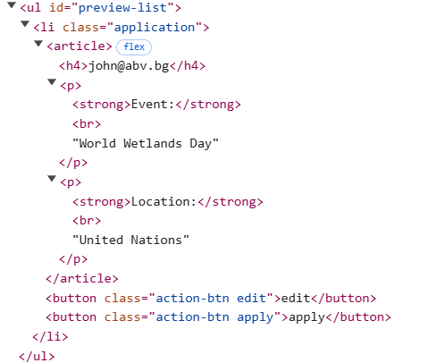

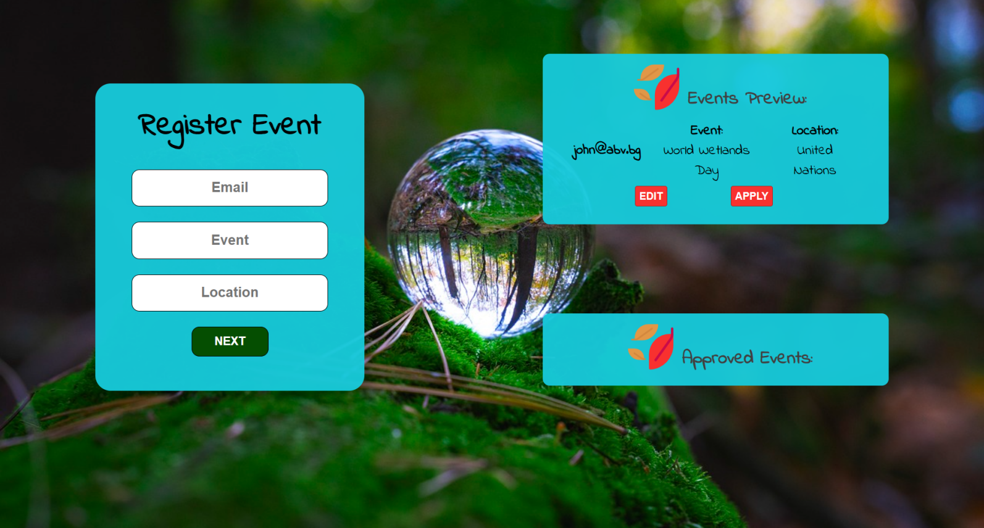

### Edit information

When the **[Edit]** button is clicked, the information from the post must be sent to the input fields on the left side and the record should be deleted from the <ul> "preview-list" and **[Next]** button must be **enabled** again.



After editing the information, add a new item to the <ul> with the updated information.

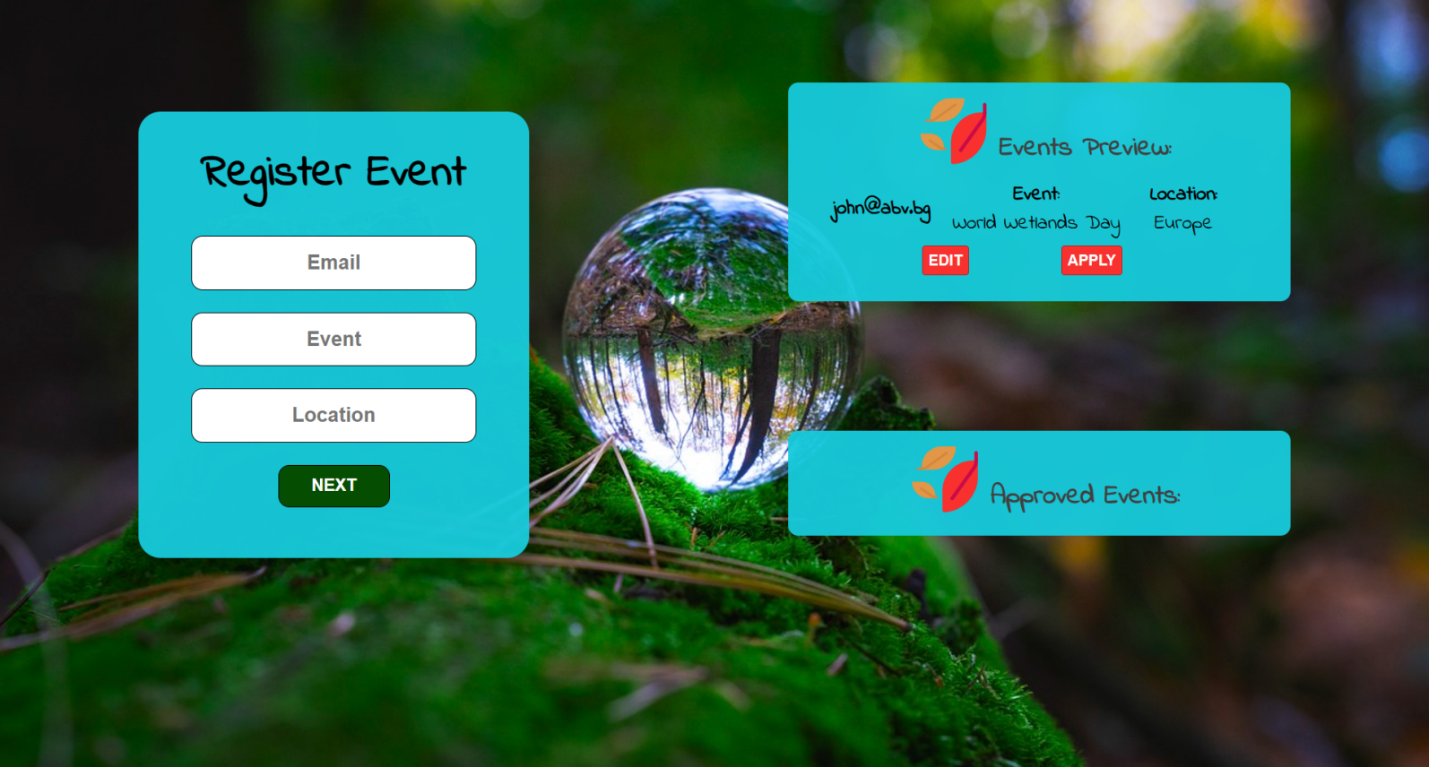

### Apply for Events

When you click the **[Apply]** button, the task must be **deleted** from the <ul>withid"preview-list" and appended to the <ul> with id "event-list".

The **buttons [Edit]** and **[Apply]** should be removed from the <li> element and **[Next]** button must be **enabled** again.

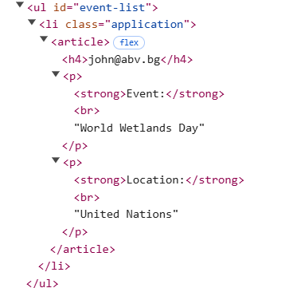

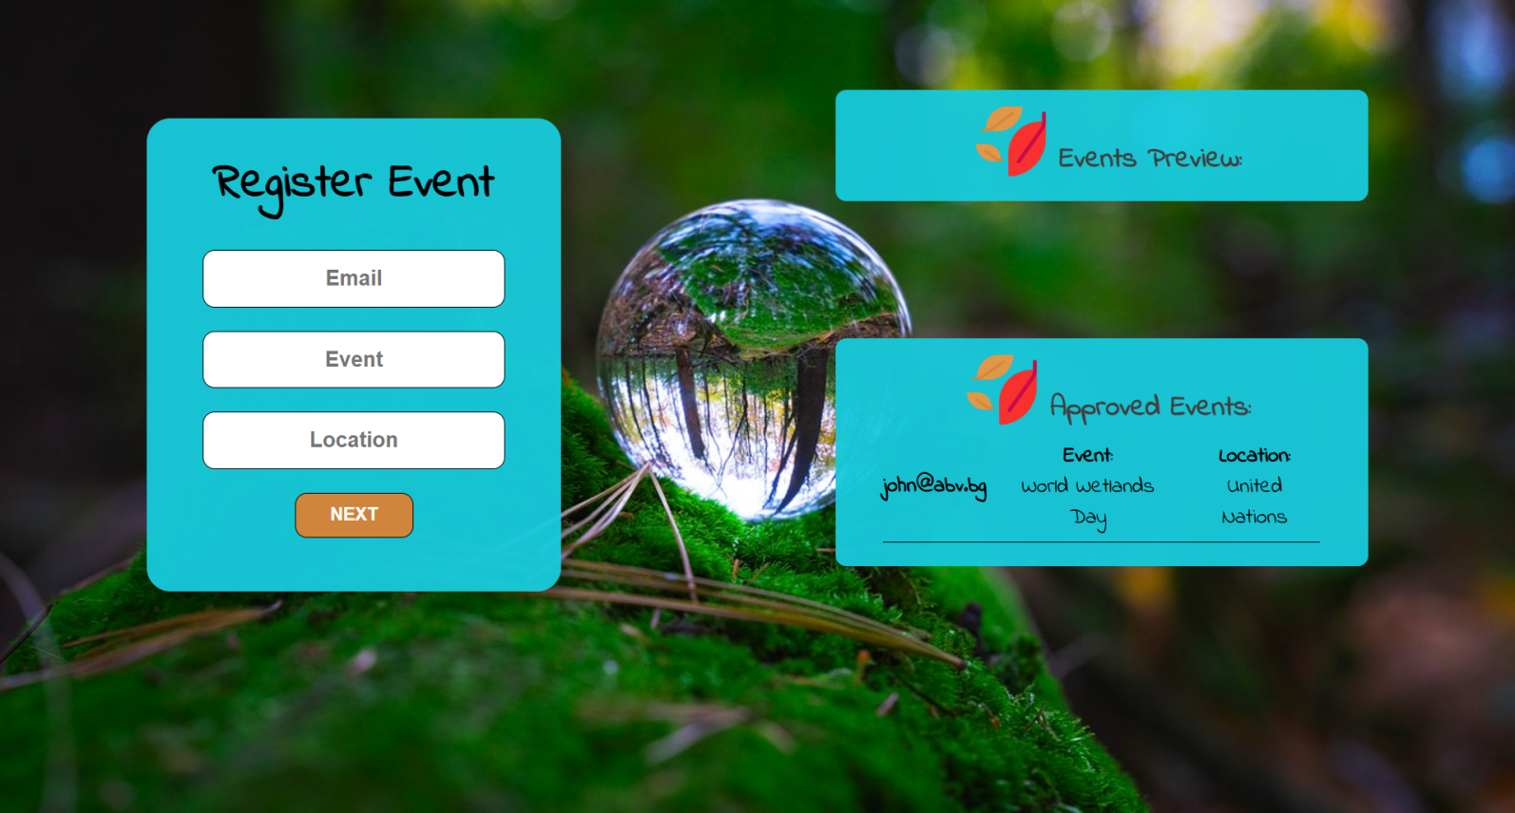

**Submission**

Submit only your **solve()** function.

## Problem 3 – Sport Tracker

**Working with Remote Data**

For the solution of some of the following tasks, you will need to use an up-to-date version of the **local REST service** provided in the lesson’s resources archive. You can [read the documentation here](https://github.com/softuni-practice-server/softuni-practice-server).

**Environment Specifics**

Please be aware that every JS environment may **behave differently** when executing code. Certain things that work in the browser are not supported in **Node.js**, which is the environment used by **Judge**.

The following actions are **NOT** supported:

* **.forEach()** with **NodeList** (returned by **querySelector()** and **querySelectorAll()**)
* **.forEach()** with **HTMLCollection** (returned by **getElementsByClassName()** and **element.children**)
* using the **spread-operator** (**...**) to convert a **NodeList** into an array
* **append()** (use only **appendChild()**)
* **prepend()**
* **replaceWith()**
* **replaceAll()**
* **closest()**
* **replaceChildren()**

If you want to perform these operations, you may use **Array.from()** to first convert the collection into an array.

### Requirements

Write a JS program that can load, create, remove and edit a list of workouts. You will be given an HTML template to which you must bind the needed functionality.

First, you need to install all dependencies using the npm install command

Then, you can start the front-end application with the npm start command

You also must start the ***server.js*** file in the ***server*** folder using the node server.js command in another console **(BOTH THE CLIENT AND THE SERVER MUST RUN AT THE SAME TIME)**.

At any point, you can open up another console and run npm test to test the **current state** of your application. It’s preferable for **all of your tests to pass locally** before you submit to the Judge platform, like this:

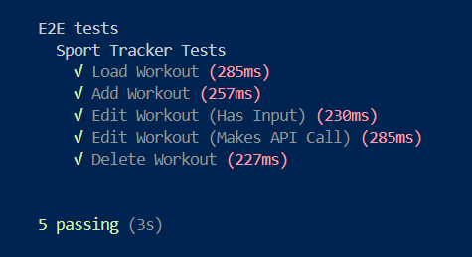

### Endpoints

* <http://localhost:3030/jsonstore/workout/>
* <http://localhost:3030/jsonstore/workout/>:id

### Load Workout

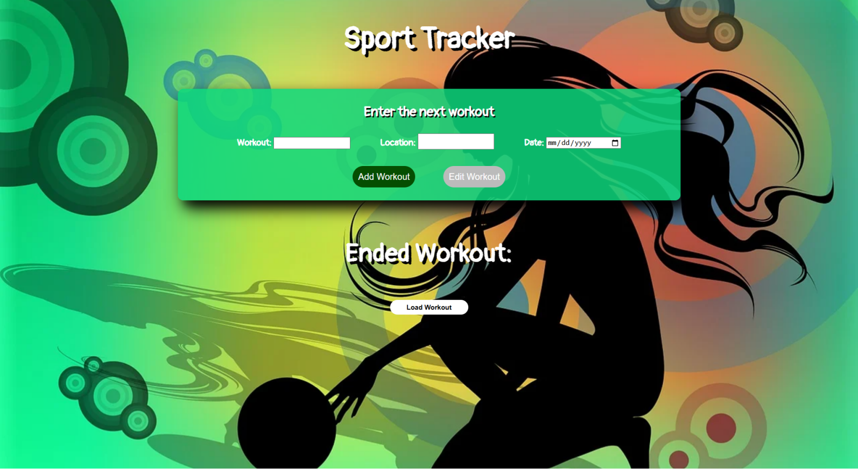

Clicking the **[Load Workout]** button should send a **GET** request to the server to fetch **all records** from your local database. You must add each workout to the<div>with **id="list". [Edit Workout]** button should be deactivated.

Each record has the following **HTML** **structure**:

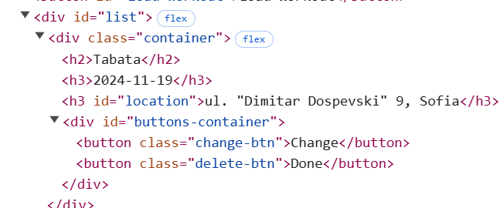

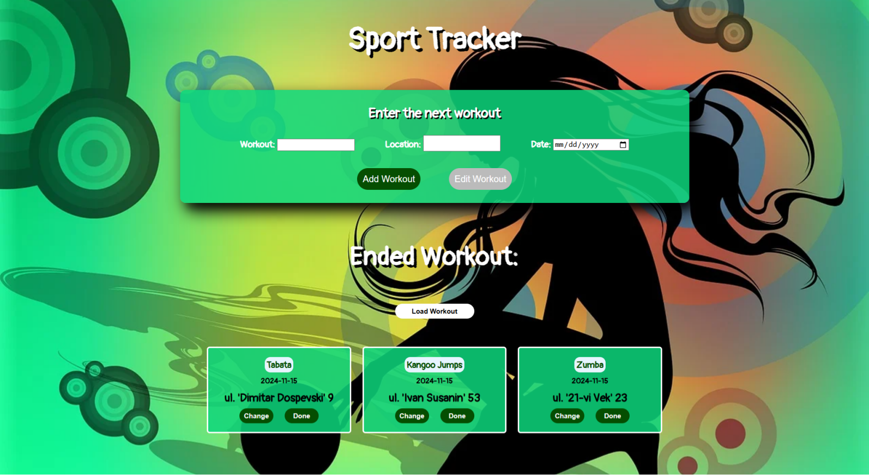

### Add а Workout

Clicking the **[Add Workout]** button should send a **POST** request to the server, creating a new scheduled workout with the **workout**, **location, and date** from the input values. After a successful creation, you should send another **GET** request to fetch all the scheduled workout, including the **newly added one** into the **Ended Workout** column. You should also **clear all the input fields** after the creation!

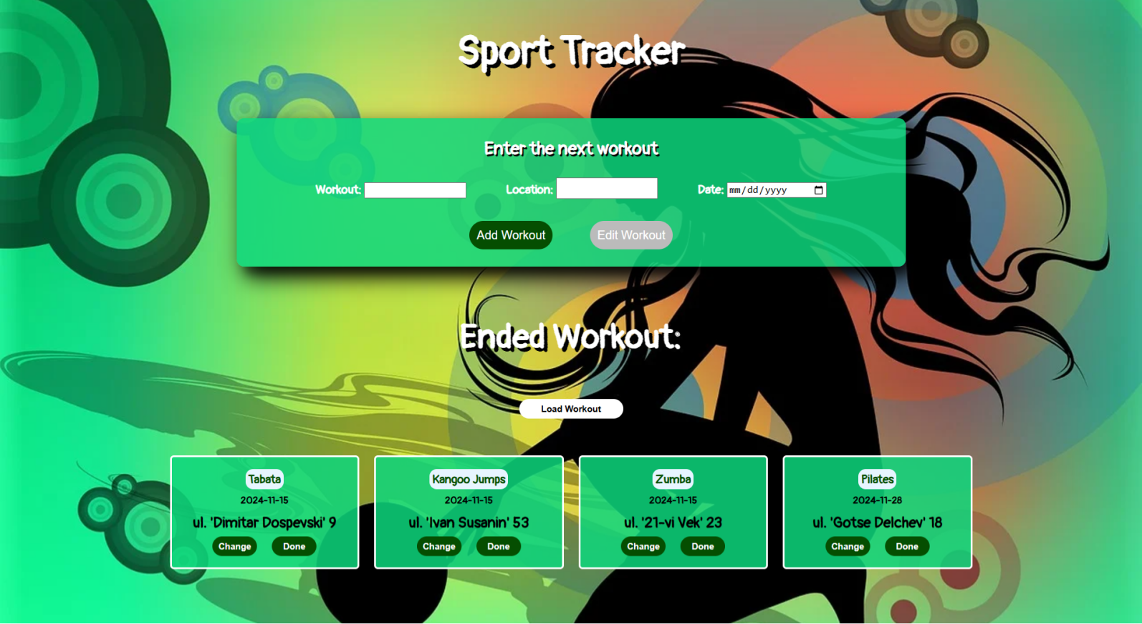

### Edit a Workout

Clicking the **[Change]** button on a record should remove the record from the DOM structure and the information about the task should be populated into the input fields above. The **[Edit** **Workout]** button **in the** **form** should be activated and the **[Add Workout]** one should be deactivated.

After clicking the [**Edit Workout]** button in the form, you should send a **PUT** request to the server to **modify the workout, location and the date** of the changed item. After the successful request, you should **fetch the items again** and see that the changes have been made. After that, the **[Edit** **Workout]** button should be deactivated and the **[Add Workout]** one should be activated.

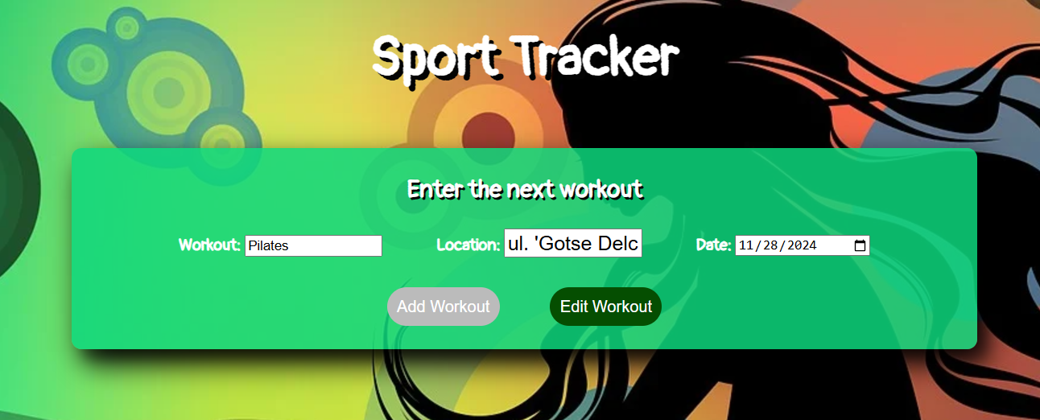

### Done

Clicking the **[Done]** button should send a **DELETE** request to the server and remove the item from your local database. After you've removed it successfully, **fetch** the items **again**.

### Submitting Your Solution

Select the content of your working folder (the given resources). Exclude the *node_modules* & *tests* folders. Archive the rest into a **ZIP** file and upload the archive to Judge.

